**Experiment No. 4-Implementation of Fuzzy Extension Principle Using Python**

**Aim:** To implement the fuzzy extension principle, which extends a given fuzzy set to a larger universe of discourse while maintaining the original set's properties.

**Learning Objective:** To understand and implement the fuzzy extension principle by extending a fuzzy set to a larger domain while preserving its membership properties.

**Tools:** Python 3 language and IDLE

**Theory:**

**Fuzzy Extension Principle**

The fuzzy extension principle is a fundamental concept in fuzzy set theory and fuzzy logic. It deals with extending a fuzzy set from a given domain to a larger or different domain while maintaining its inherent membership properties.

**Key Concepts:**

1. **Fuzzy Sets:**
   * Fuzzy sets are an extension of classical set theory where membership is expressed with degrees ranging between 0 and 1. Unlike classical sets where an element either belongs to the set or not, fuzzy sets allow partial membership.
   * A fuzzy set $A$ is characterized by its membership function $μ_{A}(x)$ which maps elements $x$ in the universe of discourse $X$ to a value in the interval [0, 1].
2. **Domain and Membership Function:**
   * The domain of a fuzzy set is the range of values over which the membership function is defined.
   * The membership function $μ_{A}\left(x\right)$ provides the degree of membership of each element $x$ in the fuzzy set $A.$
3. **Extension Principle:**
   * The fuzzy extension principle involves expanding the membership function of a fuzzy set from an original domain to a new, possibly larger, domain.
   * The principle ensures that the properties of the fuzzy set are preserved in the new domain, often using techniques like interpolation.
4. **Linear Interpolation:**
   * Linear interpolation is a common method used to extend the membership function. It estimates membership values in the new domain based on the values in the original domain.
   * This technique assumes that the membership function changes linearly between known points.

**Code & Output:**

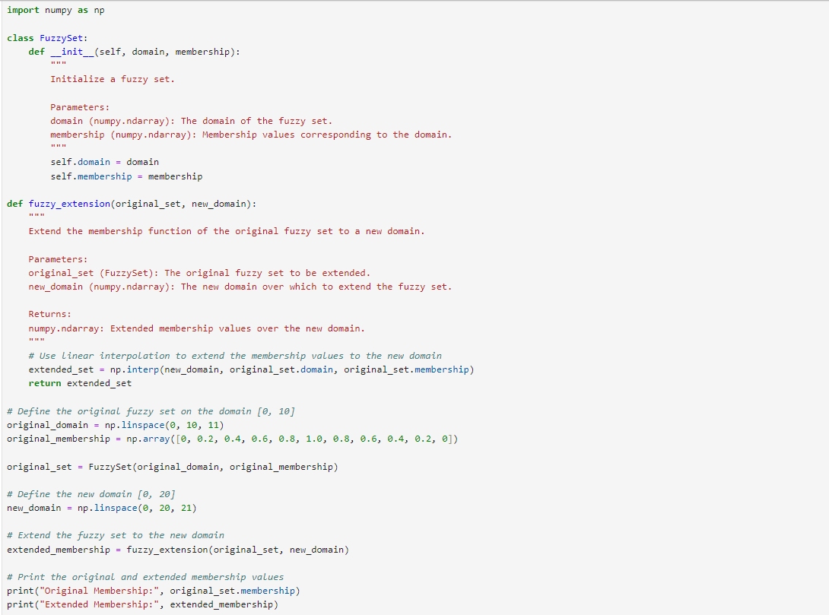 Implementation of the fuzzy extension principle using Python and the numpy library:

**Original Membership**: Membership values over the original domain [0, 10].

**Extended Membership**: Membership values interpolated to the new domain [0, 20].



This demonstrates how the fuzzy set is extended and how the membership values are interpolated to fit the new domain.

**Learning Outcomes:** The student should have the ability to

LO4.1: Apply the fuzzy extension principle to expand a fuzzy set's domain.

LO4.2: Implement linear interpolation to extend the membership function of a fuzzy set using Python.

LO4.3: Analyze and interpret the extended membership values in the context of fuzzy logic.

**Course Outcomes:** Upon completion of the course, students will be able to apply fuzzy set theory, execute fuzzy operations, extend fuzzy sets to new domains, and analyze fuzzy data.

**Conclusion:**

____________________________________________________________________________________________________________________________________________________________________________________________________________________________________________________________________________________________________________________________________________________________________

|  |  |  |  |  |
| --- | --- | --- | --- | --- |
| **Correction** | **Formative** | **Timely** | **Attendance /** |  |
| **Parameters** | **Assessment** | **completion of** | **Learning** |
|  | **[40%]** | **Practical [ 40%]** | **Attitude** |
|  |  |  | **[20%]** |
| **Marks** |  |  |  |
| **Obtained** |

For Faculty Use